
Job Description

CORE back office post number: 527212/1

Job Title | Head of Transnational Education
School/Department/College | COMMS
Job Grade | 8
Career Pathway | MPSS

Organisation Structure
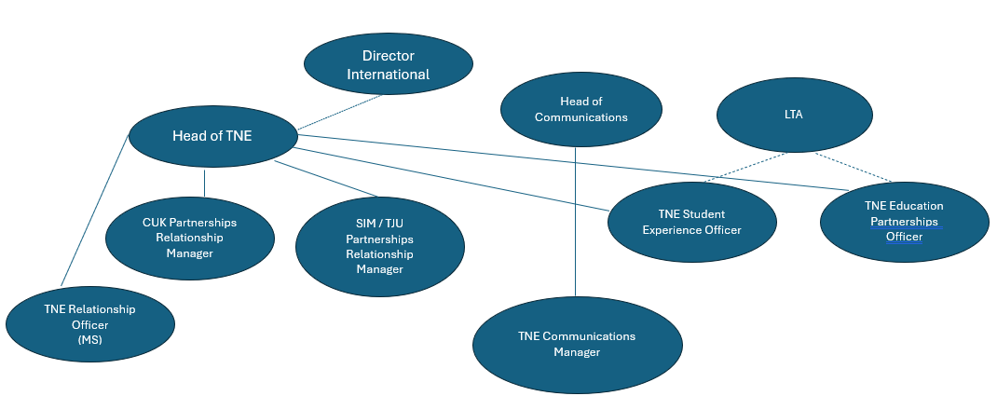
Post Responsible To | Director of International
Posts Responsible For | 2 x Partnerships Relationship Managers  TNE Student Experience Officer  TNE Education Partnerships Officer  TNE Relationship Officer

Duties and Responsibilities
Key Duties

- Execute the vision and strategy for TNE at Cardiff University.
- Manage the TNE Team and ensure it works effectively and exemplifies best practice to meet Cardiff’s TNE aims and objectives.
- Provide direction, management and leadership for all Cardiff TNE projects, ensuring they meet the strategic needs of Cardiff University and alignment with the global strategy.
- Act as a source of expertise on the legal, regulatory and compliance aspects of TNE.
- Develop and implement a university-wide TNE matrix and evaluation tool.
- Identify, negotiate and deliver TNE agreements with a range of partners, engaging legal expertise and working across a span of jurisdictions. This will include complex financial and legal negotiations.
- Be a leading voice of authority on TNE, and a source of expertise, advice and support to the wider university on TNE.
- Act as a strategic advisor to the Vice-Chancellor, Chief Operating Officer and the Pro Vice- Chancellor / TNE Academic lead on all TNE matters, providing strategic and operational advice and support on emergent issues.
- Collaborate with senior colleagues across the University, working with the Director of International to devise, implement, and monitor TNE strategies.
- Act as the key international point of contact for TNE at Cardiff University.
- Actively promote the internationalisation aims of Cardiff University.
- Undertake international travel up to 12 weeks per year.
- Undertake some evening, weekend and bank holiday work to fulfil the functions of the role.

Person Specification
Essential Criteria (maximum of 10)
Qualifications and Education
- Professional qualification/relevant degree

Knowledge, Skills and Experience
- Specialist knowledge and a comprehensive understanding of, and experience of working within, the global TNE education landscape, and in particular the legal and financial elements of TNE
- Experience of developing, shaping and implementing international strategy

Customer Service, Communication and Team Working
- Excellent written and oral communication skills, and the ability to understand and interpret complex information, effectively and professionally with a wide range of people
- Experience of leading and managing teams, in the UK and overseas, with a sizable budget
- A resilient, determined and confident team player; comfortable with making decisions
- The ability to create and manage strategic networks both internally and externally

Planning, Analysis and Problem solving
- Proven experience in dealing with diverse and challenging problems, and creating new solutions where no prior precedent exists, especially in relation to transnational education
- Ability to write and contribute to business cases for further investment in TNE
- Excellent cultural awareness, and ability to celebrate an inclusive and diverse culture embracing and championing the strength and impact of a truly global community
Desirable Criteria (if appropriate)
- Postgraduate qualification
- Experience of working in a Higher Education environment

