
Job Description

Job Evaluation Code | 003848

Job Title | TNE Partnership Relationship Manager (Cardiff University Kazakhstan)
School/Department/College | COMMS
Job Grade | 7
Career Pathway | MPSS

Organisation Structure
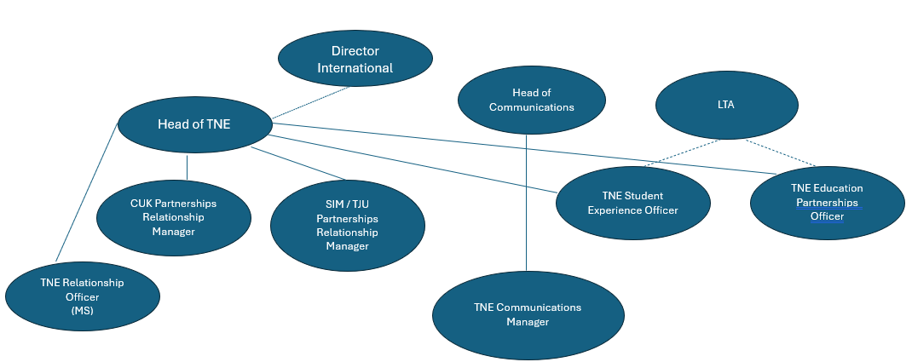
Post Responsible To | Head of TNE
Posts Responsible For | N/A

Job Purpose
Responsible for managing and strengthening the strategic and operational relationship between Cardiff University and Cardiff University Kazakhstan, providing advice, guidance and support, and leading projects within this area.

Duties and Responsibilities
Key Duties
- Provide professional advice and guidance as the primary point of contact in the relationship between Cardiff University and Cardiff University Kazakhstan, liaising with colleagues across Cardiff University and Cardiff University Kazakhstan to support the development of the branch campus and ensure strategic objectives are met.
- Establish strong working relationships with Cardiff University Kazakhstan leadership and professional services teams to ensure role objectives are met. Work closely with TNE leadership in Cardiff University (including COO, PVC and TNE Academic Lead for TNE and Director of International).
- Take responsibility for monitoring Cardiff University Kazakhstan performance against strategic objectives and contractual obligations and produce reports on relationship performance and impact.
- Plan and deliver strategies to strengthen collaboration between Cardiff University and Cardiff University Kazakhstan including supporting campus expansion projects and cross-campus initiatives in collaboration with colleagues in Cardiff and Astana
- Manage ongoing projects and objectives relating to Cardiff University Kazakhstan that require input and support from colleagues in Cardiff.
- Work in collaboration with Cardiff University Kazakhstan on cross-cutting MOUs, their approval and management
- Build and maintain long-term relationships with external partners and stakeholders such as the Kazakhstan Embassy in UK, UK Embassy in Astana, DTI, British Council etc.
- Manage the Cardiff University TNE risk register with relation to Cardiff University Kazakhstan, producing regular performance and risk reports for senior leadership
- Ensure that the provision of high level TNE support to senior leadership in Cardiff, contributing to the development of institution wide standards and strategies for TNE.
- Support with Cardiff University TNE governance structures, including operational working groups, with particular reference to Kazakhstan.
- Develop and deliver training within TNE at Cardiff University.
- Undertake international travel up to 12 weeks per year.
- Undertake some evening, weekend and bank holiday work to fulfil the functions of the role.

General Duties
- Organise strategic visits, delegations, and events including summer schools for students.
- Support with general TNE activity as requited
- Perform other duties occasionally which are not included above, but which will be consistent with the role

Person Specification
Essential Criteria (maximum of 10)
Qualifications and Education
- Postgraduate/Professional qualification/NVQ 5 or equivalent experience
Knowledge, Skills and Experience
- Substantial experience of working within international roles
- Excellent communication, interpersonal, and stakeholder management skills
- Proven experience in working with international partners with ability to demonstrate expert professional knowledge within specialist discipline, to be recognised as an authority in the field

Customer Service, Communication and Team Working
- Able to influence senior decisions within specialist discipline that have a strategic impact
- Evidence of experience of working across cultures
- Proven ability to develop networks in order to contribute to long term developments

Planning, Analysis and Problem solving
- Evidence of ability to research and solve expansive problems using initiative and creativity; identify and propose both practical and innovative solutions
- Evidence of demonstrable knowledge of key advances within TNE
- Evidence of ability to undertake and deliver specific projects and supervise short term project teams

Desirable Criteria (if appropriate)
- Experience of working in Kazakhstan

Additional Information
N/A

